MARIAN ENGINEERING COLLEGE
KAZHAKUTTOM, TRIVANDRUM

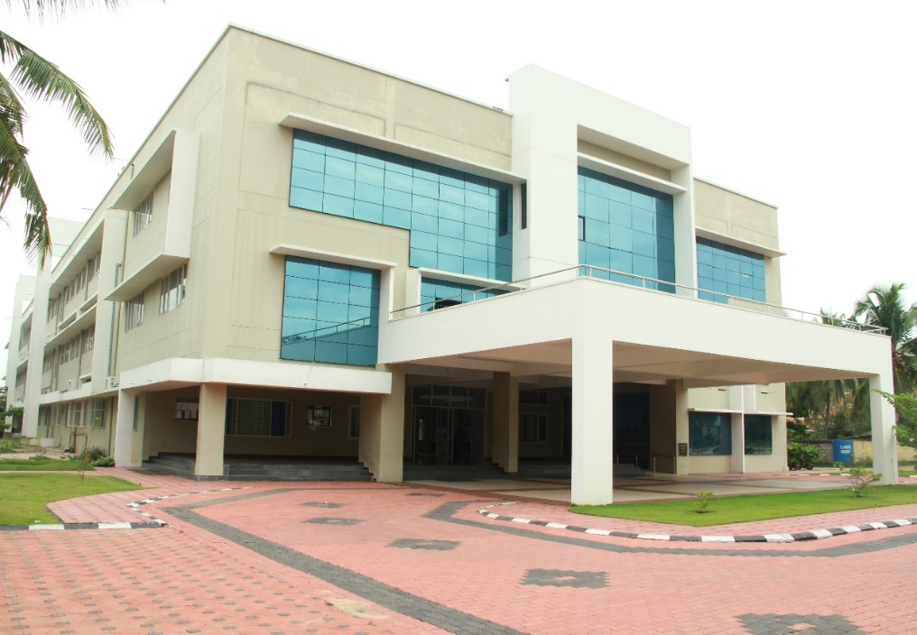

REPORT OF
INNOVATION & ENTREPRENEURSHIP DEVLOPMENT CENTER (IEDC)

For the academic year 2017-18

The activities of Innovation & Entrepreneurship Development Center (IEDC) for this year was initiated by the orientation program organised and conducted by Nodal Officer in entire classes. After the session application was invited from interested students to submit application in prescribed format. The application was shortlisted based on first come first served basis. Preference was given to students who already participated in any event or have discussed any innovative idea with IEDC Office bearers. The core team is as follows
Sl No | Name | Designation | Department
1 | Dr. M. Manoj | Nodal Officer
2 | Evan Kumar | Dept. Representative | ECE
3 | Abhiroop. V. M | Dept. Representative | ME
4 | SajiniNirmal | Dept. Representative | CSE
5 | Asha Davood | Dept. Representative | CE
6 | Sujith | Dept. Representative | EEE

Out of the submitted applications, 300 students was selected as members. The split up from each department was
Sl No | Department | Number of students
1 | ECE | 51
2 | ME | 86
3 | CSE | 56
4 | CE | 80
5 | EEE | 27
Total |  | 300

The following students were selected as Officer Bearers for one the upcoming year.
Student Team |  | Academic Year | Specialisation
CEO | Harikrishnan V S | 4th year | Mechanical
CTO | NavanitGopakumar | 4th year | Computer Science
CFO | Ajay Alias | 4th year | Mechanical
COO | Nayana B | 3rd year | Civil
CCO | Harikrishnan S | 4th year | Mechanical
CMO | NithinChandran | 4th year | Mechanical
CXO | SnehaTomy | 3rd year | Mechanical

PROGRAMS
Orientation Program by Dr. K. C. C. Nair
Initially the selected students were given an orientation program for one day on the significance of Start Up Eco system in India. The session was handled by Dr. K. C. Chandrasekaran Nair, Founder CFO of Techno park, Trivandrum.
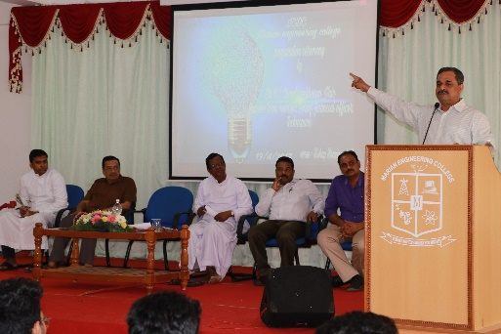
Dr. K. C. C. Nair addressing IEDC members
He addressed the students and mentioned the various support schemes for student start Up’s. The significance of developing a culture which supports the entire startup ecosystem was also pointed out. The new room of IEDC was also inaugurated by him.

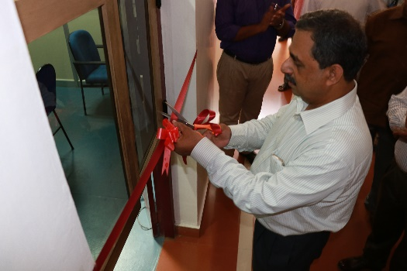
Dr. K. C. C. Nair Inaugurating IEDC Room

FDP on Significance of Research and development to Faculty members.
Keeping in mind the support that should come from the Faculty Community for developing an Ecosystem which support students for innovation and entrepreneurship activity, an FDP was organised for entire faulty community from 19th& 20th of July 2017. The schedule was

Schedule | Resource Person
Inauguration | Mr. SajiGopinath(Chief Executive Officer, Kerala Start Up Mission)
Embrace Changes for Survival | Dr. K. C. Chandrasekharan Nair
Motivate your students for innovations | Prof. S. Sivadas
How to make ordinary students to do extraordinary projects/ Help students to dream big | Mr. ArunSurendran
Relevance of Change for Survival | Infosys Senior VP Sales
Expectations from Infosys and Changing Recruitment Model | Mr. Sonu Jose , Sr. HR Associate Infosys Technologies
Reality of Core Sector Jobs | Mr. Elango P, Deputy General Manager

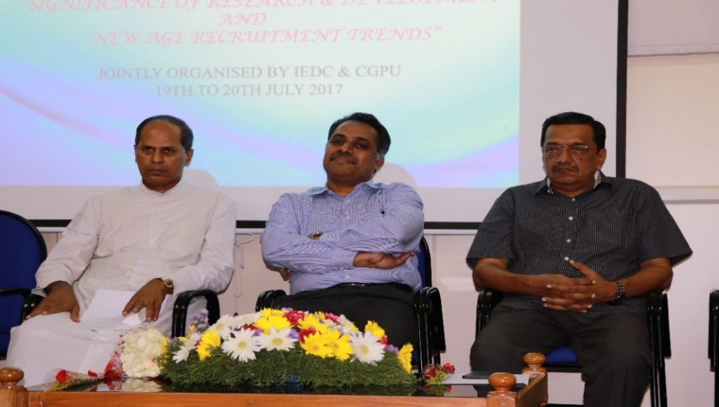
SajiGopinath, CEO, Kerala Start Up Mission, in FDP, as resource person.
KSCSTE funded workshop on SPC Scheme
The key function of IEDC in a professional college is to keep focus on newly developed technology and keep the students and public updated about it. Science Popularization scheme is formulated for popularizing new technologies among public. Faculty Members can submit projects based on current technologies. For generating awareness and to support them in writing proposals, IEDC organised a one day workshop on Science Popularization Schemes of KSCSTE on 3rd August 2017. The program was founded and supported by KSCSTE.

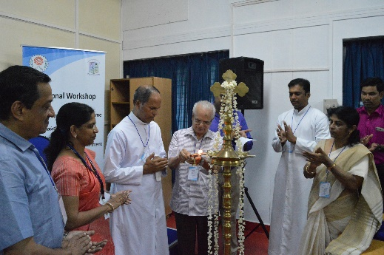
Prof. S. Sivadas, Chairman, SPC, KSCSTE, inaugurating KSCSTE funded regional workshop on SPC

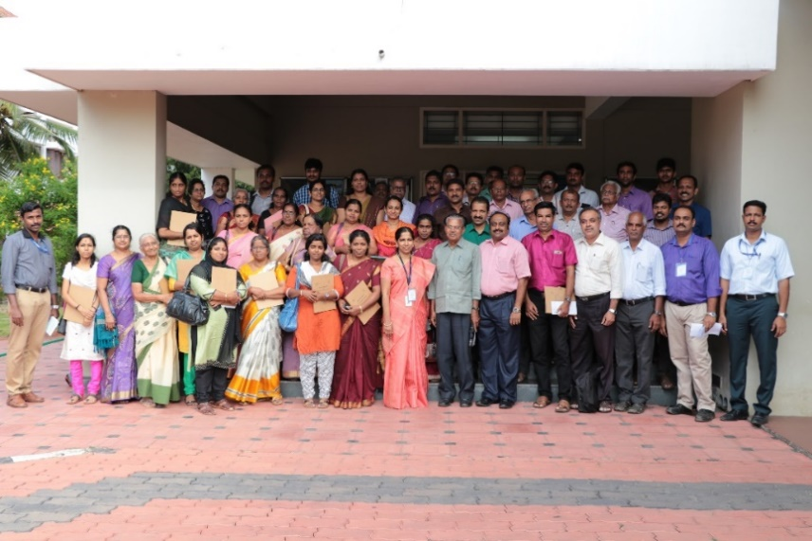
Participants of SPC Workshop
One day workshop on Waste management & Zero Energy – Zero Discharge Buildings
A one day workshop on Waste management & Zero Energy – Zero Discharge Buildings was conducted for Civil Engineering Department on 10th January 2018. The program was jointly organised and funded by Kerala State NirmithiKendram. 100 participants attended the training.

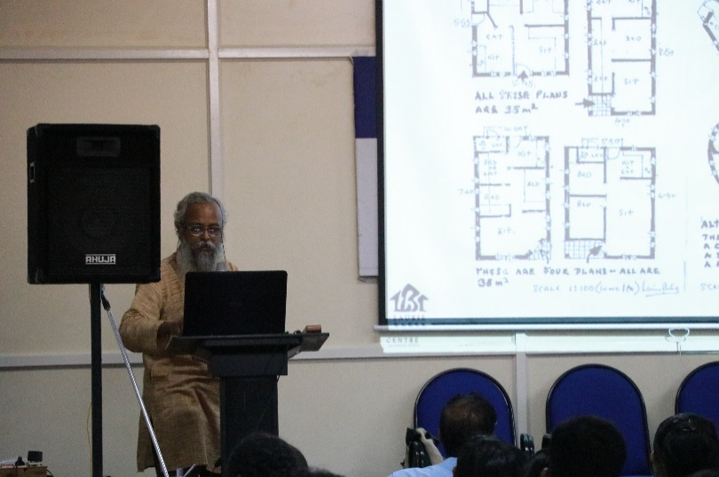
Ar. Padmakumar R.D, Member Secretary, LBC, COSTFORD handling the session

Two day Workshop on Design Thinking
The Two day workshop on entrepreneurship was organized by Kerala Start Up Mission at Marian Engineering College, Trivandrum on 20th February 2018 & 21st February 2018. Mr. Sony John Bronzon was the resource person for the workshop and 30 participants attended the workshop. The event was fully funded and supported by Kerala Start Up Mission.
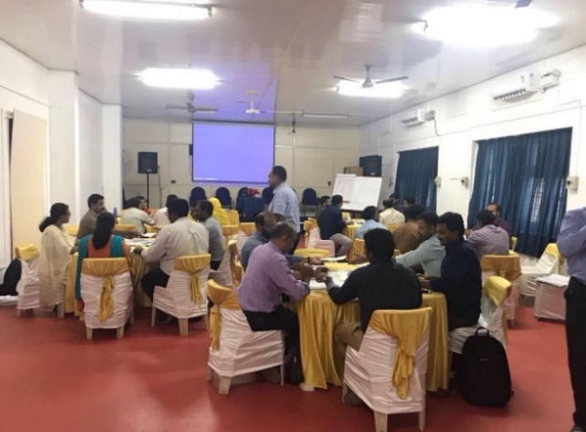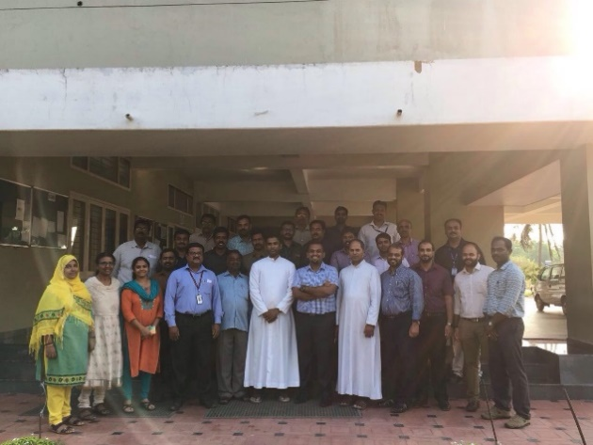
Participants of Design Thinking Workshop

National Science Day Celebrations
National Science Day was celebrated on 28th February 2018. The theme for this year was Science and Technology for Sustainable future. The sessions were handled by Dr. P. R. Sreemahadevan Pillai, Dean, University of Calicut, Prof. Shibu Krishnan, College of Engg, Trivandrum and Mr. Baiju, Asst. Engineer, Kerala Water Authority. An exhibition was also organised based on this theme. The program was fully supported and funded by KSCSTE.
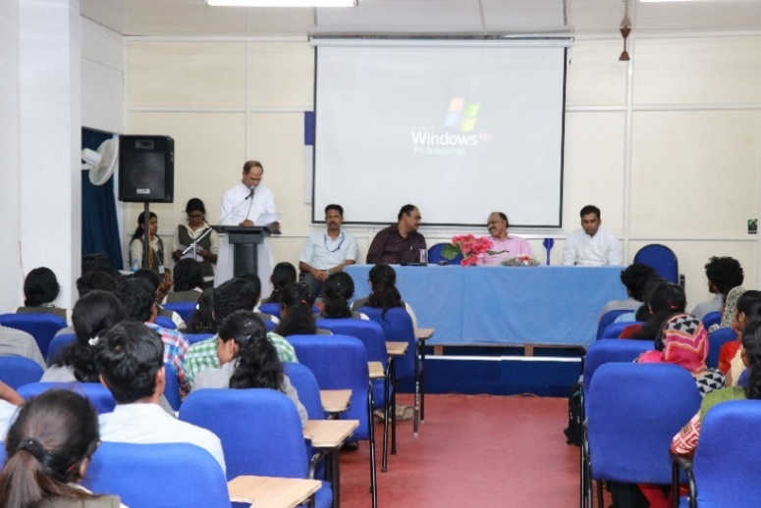
Manager Very. Rev. Wilfred. E, inagurating Natioanl Science Day celebrations
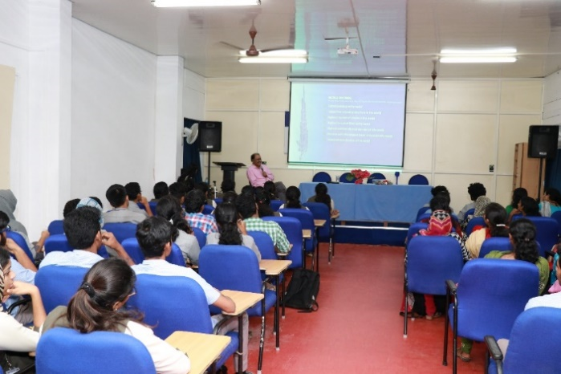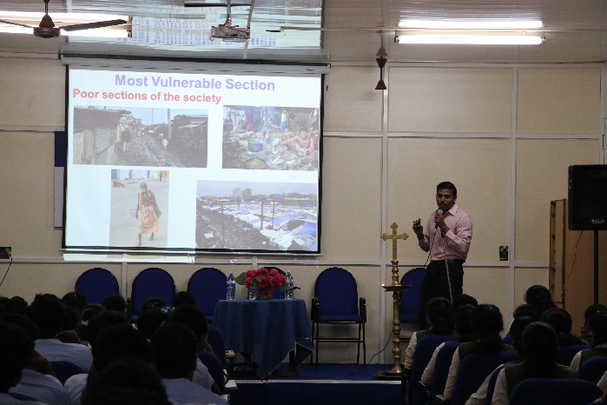
Dr. P. R. Sreemahadevan Pillai & Prof. Shibu Krishnan, handling the session

EDEN- 2K 18
Education & Entrepreneurship (EDEN) – 2k 18 was conducted from 25th January 2018 to 28th January 2018. It was a four day residential workshop for students across the state. 380 students participated in the event. The event was a mix of events from the following category.
- Motivational Talks.
- Innovation sessions.
- Idea pitching sessions.
- Meet the Entrepreneurs.
- Meet the investors.
- Govt. policies to start up’s etc.
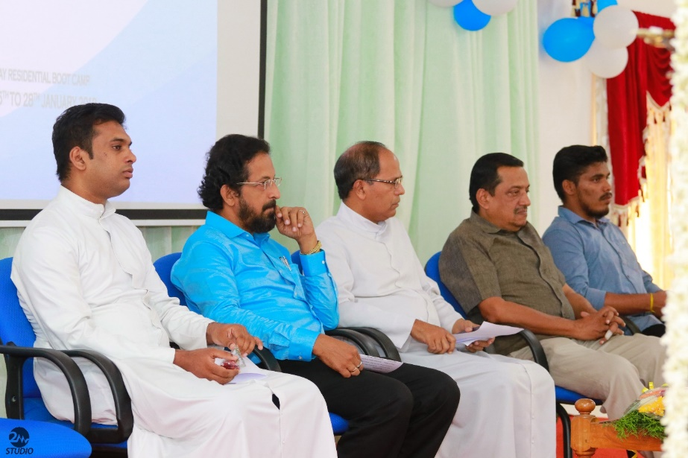
Shri. N. Shyam Mohan, Group Dirctot, VSSC during the inaugural session of EDEN 2k- 18
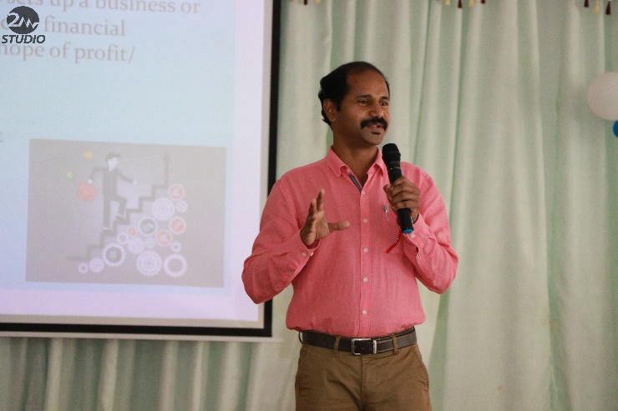
GouthamYogeeswar, District Industries Officer handling the session at EDEN 2k18.
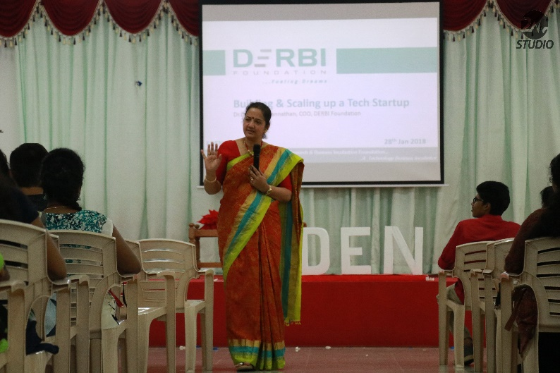

Idea to Product & Enterprise -Dr. Lakshmi Jaganathan, CEO, EDRBI Foundation, Bangalore
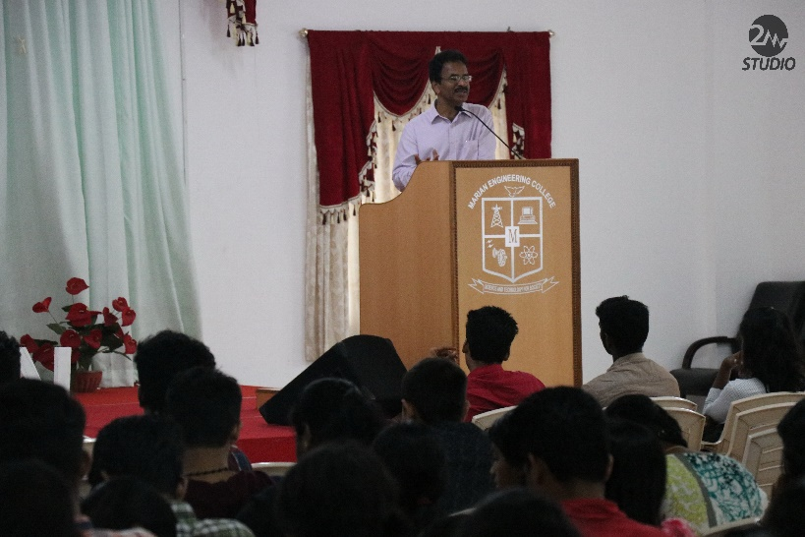
Telecommunication and entrepreneurship – Dr.S.JyothiSankar ITS. (General Manager BSNL – Kerala Circle)
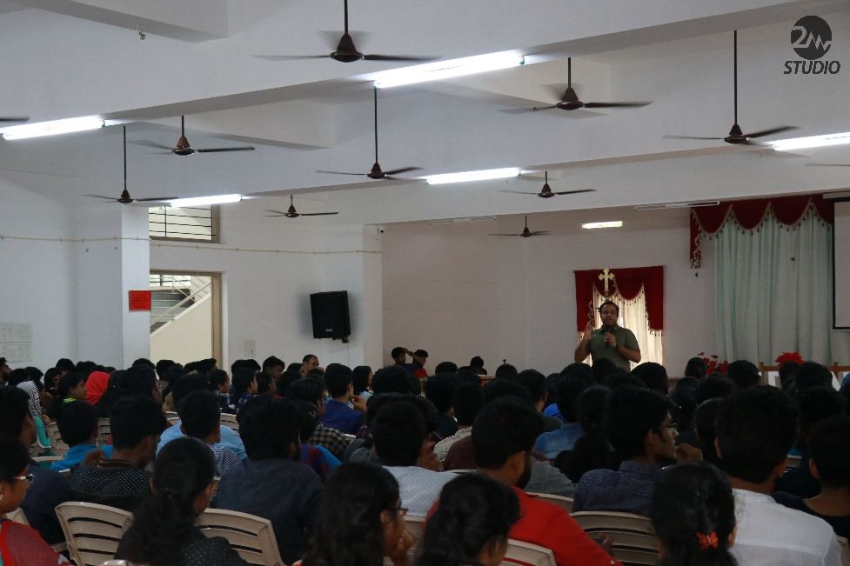
How to become a successful Entrepreneur- ArunSurendran (Strategic Officer TRINITY CET)

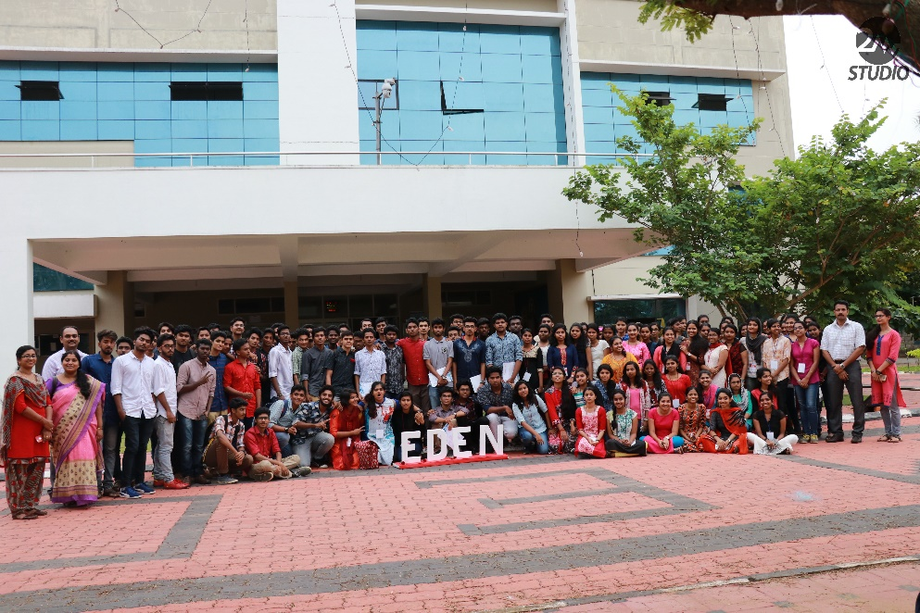
Participants of EDEN 2K 18

Meet the Entrepreneur Sessions
Success and failure stories of entrepreneurs are attracting interest of budding entrepreneurs. The can learn, share, and even mentored from them. Focusing on this, IEDC organised lot of Meet the Entrepreneurs. The following events were conducted under this head.
Name of Entrepreneur | Organization
Dr.Thomas George K | Chairman, LEAD College of Management
ReenaVivekanandan | Co-Founder SHIPS)
TripatPreet Singh | Investor Flip kart & Big Basket
Nithin O John | CEO SUBDINE
Firoz Khan | CEO Concept Group
Dr. ArunSurendran | Strategic Officer TRINITY CET
Balagopal IAS | TherumoPenpol Ltd.

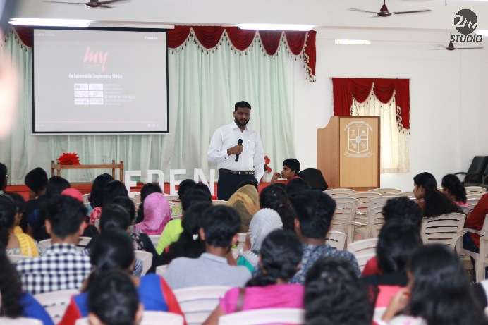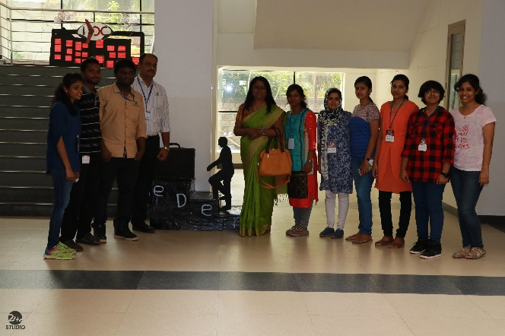
Mr. Firoz, CEO Concept Group interacting with students Ms. ReenaVivekandan, CEO, SHIPS with the students

Technical Workshops organised for students
Sl No | Title | No: of Participants | Date
1 | Blender Software | 60 | 21st& 22nd October 2017
2 | Workshop on Rivet | 84 | 24th March 2018
3 | Raspberry Pi | 80 | 27th January 2018
4 | Machine Vision | 40 | 27th January 2018
5 | Ionic Workshop | 30 | 27th January 2018
6 | 3-D printer | 100 | 27th January 2018

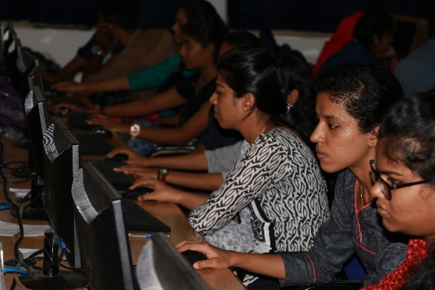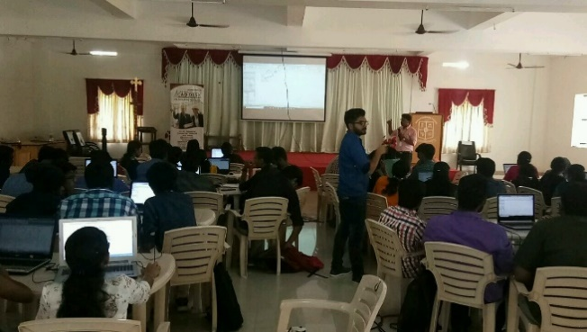
Participants of Blender WorkshopParticipants of Rivet Workshop
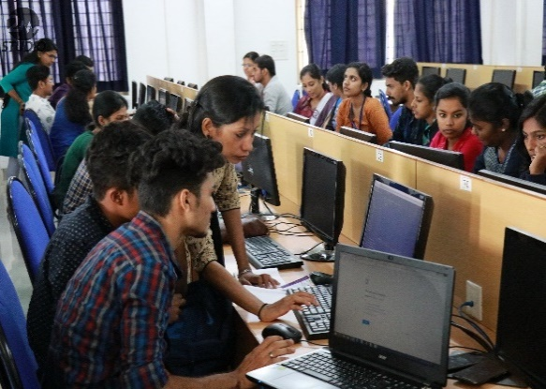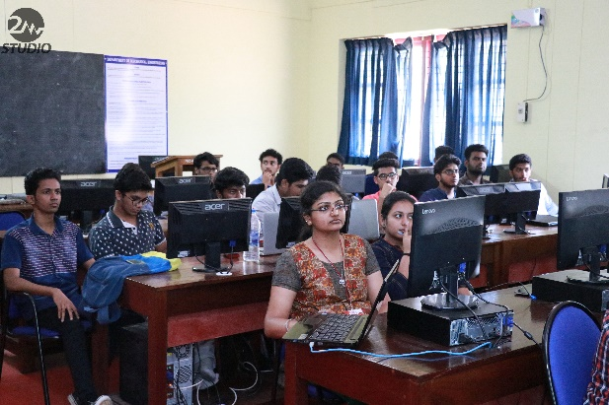
Participants of Ionic Workshop Participants of Machine Vision Workshop

EVENTS PARTCIPATED

- Team IEDC participated in IEDC SUMMIT Organised by KSUM at Angamally on 18/08/2017

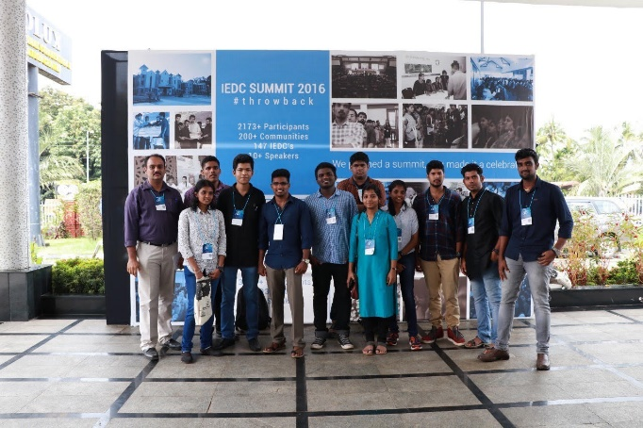

- Team IEDC participated in YES CAN 2018 organised by KSIDC on 12th September 2017 at Cochin.

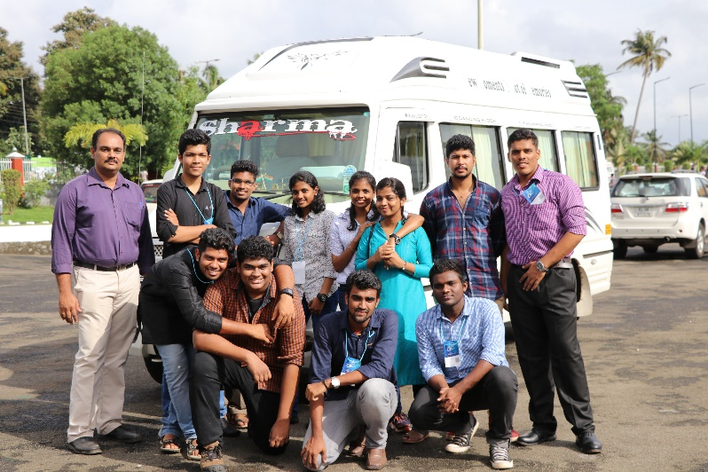

- Delegation team of IEDC, which includes 30 students and two faculy visited TIMed, the incubation center of SCTIMST on 5th October 2017.
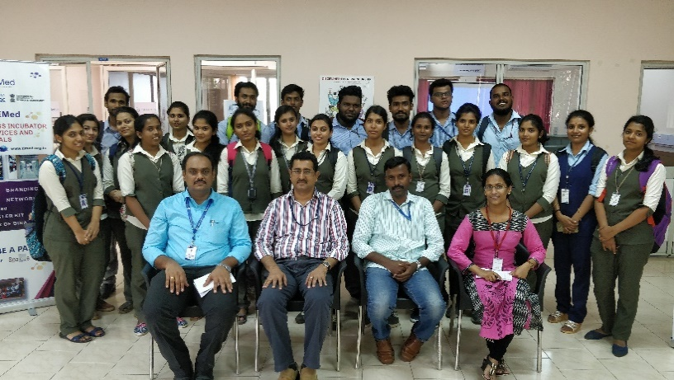
- A three member faculty delegation went to DERBI Foundation, the private incubator in Bangalore.

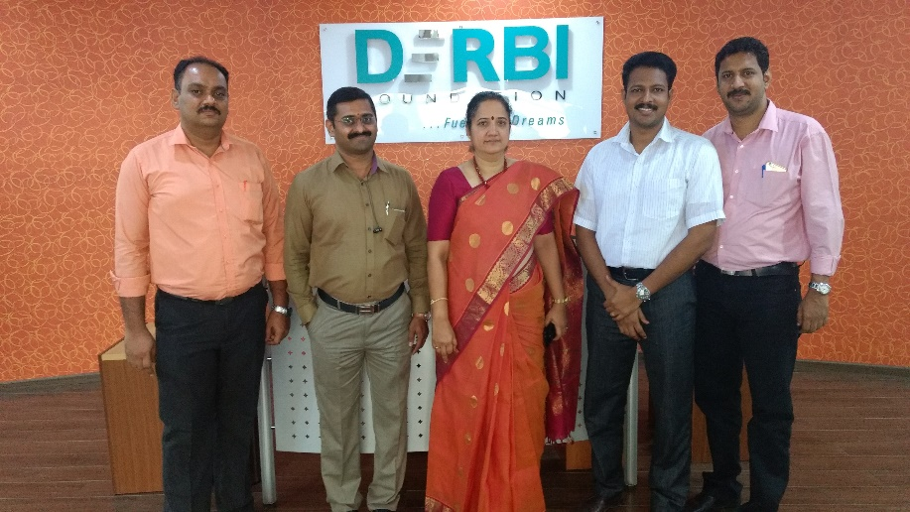

IEDC TO SCHOOLS

In continuation with the suggestion form KSUM, Marian IEDC extended its operation to the nearby schools by offering programs to High School students. The program was formulated as a three hour session, which focused on general awareness about innovation & Entrepreneurship Development. Soft Skill development was conducted by Artil Solutions, the Start Up which was registered in IEDC. The program was conducted at Pallithura High School on 2nd January 2018 and at JyothiNilayaam School at 5th January 2018.

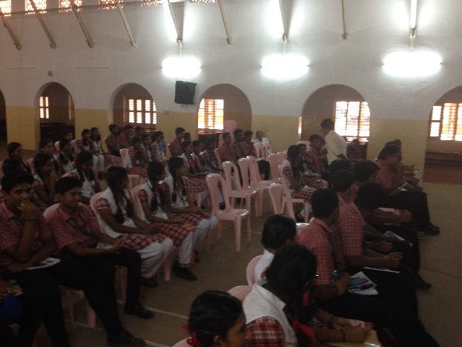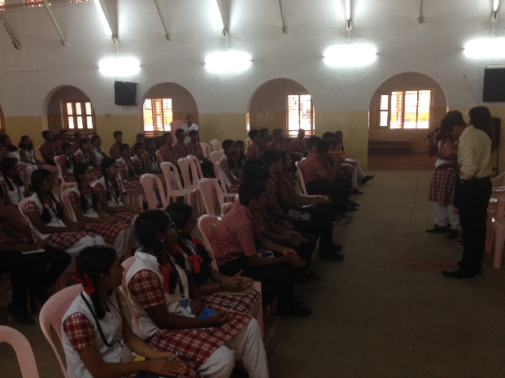
Marian IEDC event at JyothiNilayam School

Participation in various competitions & Recognitions Achieved by Students.
- Marian IEDC team submitted 9 proposal for Jack fruit Challenge by KTU. One team was selected in the final 20 list.
- 12 project proposals submitted under TDAP Scheme of KSCSTE and awaiting funding.
- One project was selected for funding under INNOVATE scheme of KSCSTE. The students of this project Ms. Namitha. B., Ms. Nayana. B, Ms. MekhnaGopal& Ms. Parvathy. S. Nair of S6 Civil represented the college in KTU Tech Fest with this project.
- Three proposals was submitted to IDEA DAY organised by KSUM.
- Four proposals was submitted to Rural Innovators Meet (RIM 2018), out of which two got selected. The two projects was
- Low cost Roof Tiles by Gouri& Team(S8 CE)
- Paper Manufacturing form coconut husk by Michael(S6CSE)
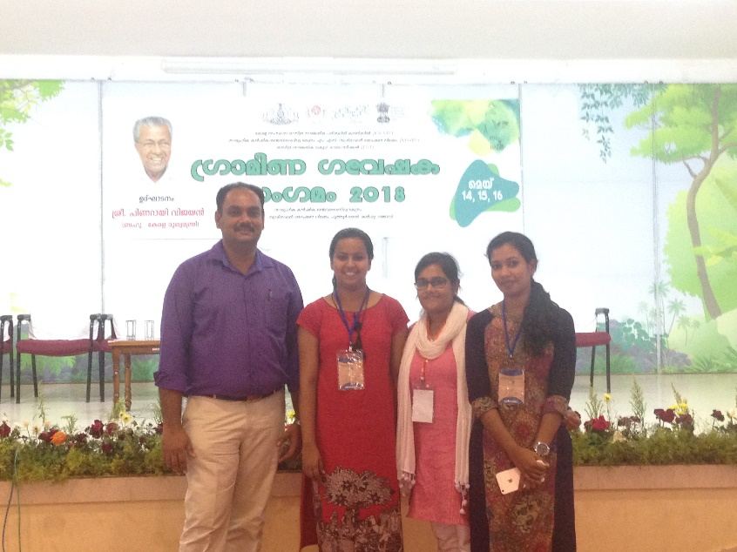
Participants of RIM 2018
- A team from final year Mechanical Engineering, headed by IEDC CEO, Mr. Harikrishnan won prize at “TECH To FARM” Event organised by IIT Madras. The project was “Nutmeg Harvester”&“Pepper Harvester”.
PARTICIPATION IN IDEA DAY
The following students participated in Idea Day contest organised by KSUM.
Date | 4/11/2017(6th idea Day) | 4/11/2017(6th idea Day) | 4/11/2017(6th idea Day)
Name of students applied | Jasiya J S | Akhila. A | Sibi Krishna
Department/Year | ECE/ 4th | Civil/4th | Mechanical/4th

PATENTS FILED THROUGH IEDC
Two patents were filed this year through IEDC.
Sl No | Name of Student | Title | Patent Application No:
1 | Shibi Krishna(S8 ME) | Fully Automated Rubber Tapping Drone | 201741037689
2 | Brijesh. B. R (S8 EEE) | Automatic Tea Leaf Plucking Machine | 201741037699

FUNDS RECEIVED BY IEDC
The following funds were received by IEDC through proposals submitted for conducting various programs.
- Rs 3.5 lakhs for proposal submitted by Dr. M. Manoj, Nodal Officer, under Science Popularization Scheme of KSCSTE, Govt. of Kerala
- Rs 1.6 lakhs for IEDC proposal for conduction of regional workshop from DST.
- Rs 25000 from Nirmithi Kendra for conducting workshop on WASTE MANAGEMENT & ZERO ENERGY-ZERO DISCHARGE BUILDINGS
- Rs 20000 for celebrating National Science Day.
- Rs 100000/- as reward from KSUM for one among the best performing IEDC in state (Was awarded to 31 IEDC’s out of existing 165).

EMPANELMENTS FOR MARIAN IEDC
- Our college is empanelled as one of the Nodal Center for PMYUVA (PrathanMantri YUVA Yogana). Dr. M. Manoj(IEDC Nodal Officer) and Dr. Sheeja Augustine( Associate Professor, CSE) are trained by Ministry of HRD, Govt. of India, as faculty facilitators for the program.
- Our College has been empaneled under State Resource Center, Govt. of Kerala for continued skill improvement and technical enhancement for engineering graduates

START UP COMPANIES REGISTERED THROUGH IEDC
The following Start Up Companies were registered through IEDC this year.
Sl No | Company Name | CEO | Product/ Service
1 | Artil Solutions | Harikrishnan(S6 CSE) | Service
2 | WerelionTechnilogies | NavneethGopakumar | Product
3 | TAADZ ELECTROTECZ | Akhil(S8EEE) | Product/ Service
4 | V4U | Akhil. V(S8 EEE) | Service

Dr. M.Manoj
Nodal Officer

